Title: Application specific access polices using Zscaler private Access(ZAP)

GROUP DETAILS

S.NO | NAME | COLLEGE NAME | CONTACT
1 | Jane veronica.M | KSG COLLEGE OF ARTS AND SCIENCE | veronicajane525@gmail.com
2 | Monisha.S | KSG COLLEGE OF ARTS AND SCIENCE | crazymonisha05012006@gmail.com
3 | Vinoth kumar.M | KSG COLLEGE OF ARTS AND SCIENCE | massmass4757@gmail.com
4 | Hariharan.S | KSG COLLEGE OF ARTS AND SCIENCE | hharan66196@gmail.com

INTRODUCTION

Zscaler Private Access (ZPA) is a cloud-delivered zero-trust solution designed to provide secure, seamless access to private applications without exposing the broader enterprise network. Unlike traditional VPNs that grant users wide-ranging network access, ZPA enforces application-specific access policies, ensuring that users connect only to the applications they are explicitly authorized to use. This approach strengthens security, reduces risk, and enhances user productivity in modern hybrid work environments.

Zscaler Private Access (ZPA) introduces application-specific access policies as part of its zero-trust architecture, ensuring that users connect only to the applications they are explicitly authorized to use rather than gaining broad network-level access. Traditional VPNs often expose entire networks, creating opportunities for lateral movement and increasing the attack surface, whereas ZPA segments access at the application level, making unauthorized resources invisible. These policies are centrally defined and dynamically enforced based on identity, role, device posture, and contextual factors such as location or time of access, with seamless integration into identity providers like Azure AD or Okta. By applying granular rules, organizations can grant employees, contractors, or third parties tailored access to only the applications they need, thereby reducing risk, improving compliance with regulations such as GDPR and HIPAA, and enhancing user experience by eliminating VPN complexity. This approach supports hybrid and cloud environments, scales easily across diverse infrastructures, and embodies the principle of least privilege, ensuring that users only access what is necessary while keeping everything else hidden. In project terms, application-specific access policies using ZPA provide a modern, secure, and efficient framework for enterprise connectivity, aligning with digital transformation goals and the evolving demands of remote and distributed workforces.

ABSTRACT

Zscaler Private Access (ZPA) is a modern zero-trust solution that provides secure connectivity to private applications without exposing the enterprise network. Unlike traditional VPNs, which grant broad network-level access, ZPA enforces application-specific access policies, ensuring that users connect only to the applications they are authorized to use.
These policies are centrally defined and dynamically enforced based on identity, role, device posture, and contextual factors such as location or time of access. By integrating with identity providers, ZPA enables organizations to implement granular, least-privilege access controls for employees, contractors, and third parties.
Application-specific access policies reduce the attack surface by making unauthorized applications invisible, thereby preventing lateral movement within the network. This approach also supports compliance with regulatory frameworks like GDPR and HIPAA, while improving user experience by eliminating the complexity of VPNs.
In project terms, ZPA provides a scalable, secure, and efficient framework for enterprise connectivity. It aligns with digital transformation goals and supports the evolving demands of hybrid and remote work environments, making application-specific access policies a critical component of modern IT security strategies.
Policies are centrally defined and dynamically enforced based on identity, role, device posture, and contextual factors such as location or time of access, with seamless integration into identity providers like Azure AD and Okta. By applying granular rules, organizations can tailor access for employees, contractors, and third parties, thereby strengthening security while supporting compliance with regulatory frameworks such as GDPR and HIPAA. In addition, ZPA improves user experience by eliminating the complexity of VPNs and providing fast, seamless connections across on-premises, cloud, and hybrid environments. Application-specific access policies in ZPA thus embody the principle of least privilege, offering a scalable, secure, and efficient framework for enterprise connectivity that aligns with digital transformation initiatives and the evolving demands of hybrid and remote workforces.

USE CASE SCENARIOS

1.Secure Access for Remote Employees
Scenario:
Employees working from home need access to internal HR, finance, or project management tools.
Policy Implementation:
- Allow access to specific applications only
- Validate user identity via SSO / MFA
- Verify device posture (managed corporate device)
Example:
- Finance employees → Access to Finance App
- HR employees → Access to HR Portal
Benefit:
Prevents employees from accessing unrelated internal systems.

2.Third-Party Vendor Access
Scenario:
External vendors require access to internal applications for maintenance or support.
Policy Implementation:
- Grant vendor access only to the required application
- Restrict by time-based policies
- Block lateral movement across network
Example:
- Vendor allowed access to Database Admin Portal only
Benefit:
Eliminates the risk of exposing the full corporate network.

3.Contractor / Temporary Workforce Access
Scenario:
Short-term contractors require access to development tools or ticketing systems.
Policy Implementation:
- Create role-based application access
- Enable automatic access expiration
Example:
- Contractor → Access to DevOps dashboard for 30 days
Benefit:
Temporary users cannot access sensitive corporate systems

4.BYOD Secure Access
Scenario:
Employees access corporate applications using personal devices.
Policy Implementation:
- Verify device compliance
- Restrict access to browser-based applications only
- Block file downloads if device is unmanaged
Benefit:
Protects corporate data on non-managed devices.

5.Multi-Location Branch Office Access
Scenario:
Employees from different office locations access centralized applications.
Policy Implementation:
- Apply location-based access control
- Restrict high-risk locations
- Monitor user sessions
Benefit:
Improves security for globally distributed workforces.

6.Privileged Admin Access
Scenario:
System administrators require access to critical infrastructure systems.
Policy Implementation:
- Enable step-up authentication
- Restrict by device type + user role
- Allow access to specific admin tools only
Example:
- Network Admin → Access to Network Management Portal only
Benefit:
Reduces insider threats and credential misuse

Stage1

Title: owasp top 10 categories and vulnerabilities

Overview

s.no | vulnerabilities | CWC/CVE number
1 | Incorrect Default Permissions | 276
2 | Active Debug Code | 489
3 | Unimplemented or Unsupported Feature in UI | 447
4 | Insufficient Entropy | 331
5 | Improper input validation | 20
6 | Interpretation conflict | 436
7 | Improper Authentication | 287
8 | Untrusted search path | 426
9 | Insufficient logging | 778
10 | Divide by zero | 369

Report:

- Vulnerability Name: Incorrect Default Permission

CWE/CVE : CWE-276

OWASP/SANS Categories:A01:2025 Broken Access Control

Description:
During installation, installed file permissions are set to allow anyone to modify those files.
Business Impact:Broken Access Control refers to failures in enforcing who is allowed to access what in an application. When access controls are not properly implemented, users can view, modify, or delete data that they should not be able to access.

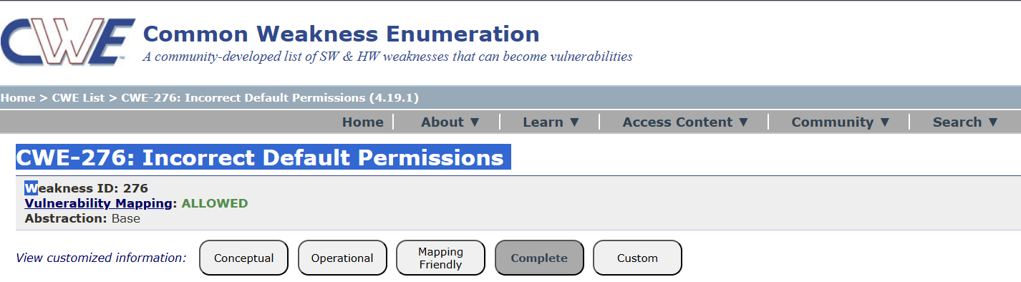

2.Vulnerabilities Name:Active Debug Code

CWE/CVE : CWE-489

OWASP/SANS Categories:A01:2025 Security Misconfiguration

Description: The product is released with debugging code still enabled or active.

Business Impact: Security Misconfiguration (sometimes mistakenly referred to as A01) occurs when security settings in applications, servers, cloud services, or frameworks are incorrectly configured or left with default settings. These mistakes create vulnerabilities that attackers can exploit.

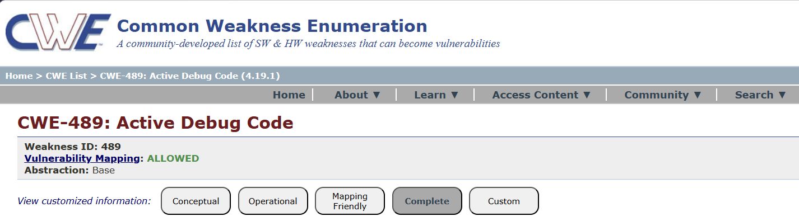

3.Vulnerabilities Name: Unimplemented or Unsupported features in UI

CWE/CVE : CWE-447

OWASP/SANS Categories: A01:2025 Software Supply Chain Failures

Description: A UI function for a security feature appears to be supported and gives feedback to the user that suggests that it is supported, but the underlying functionality is not implemented.
Business Impact: Unimplemented or Unsupported Features in the UI occur when a user interface displays options, buttons, or functions that are not fully implemented, deprecated, or not supported by the backend system. This issue can create security, usability, and operational risks for an organization.
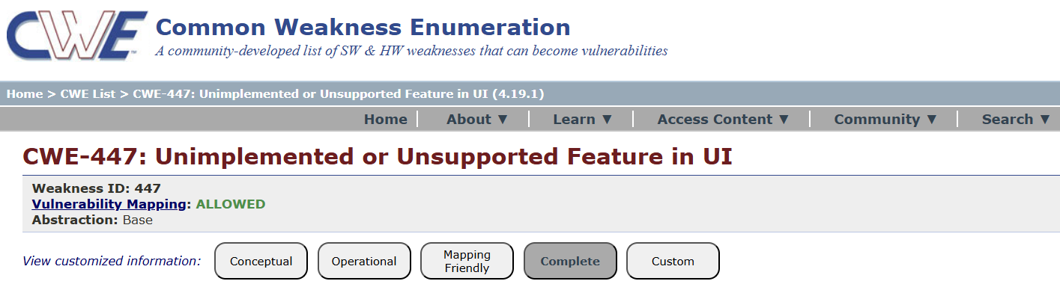

4.Vulnerabilities Name:Insufficient Entropy

CWE/CVE : CWE-331

OWASP/SANS Categories:A01:2025 Cryptographic Failures

Description:The product uses an algorithm or scheme that produces insufficient entropy, leaving patterns or clusters of values that are more likely to occur than others.

Business Impact: Cryptographic Failures (sometimes incorrectly labeled as A01) refers to weaknesses in how an application protects sensitive data using encryption. This happens when data is not encrypted, weak algorithms are used, keys are poorly managed, or encryption is improperly implemented.

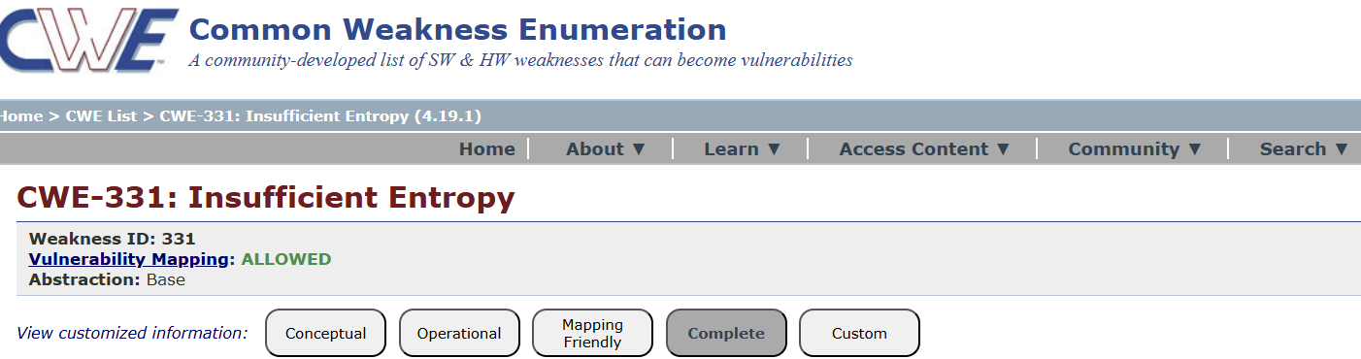

5. Vulnerabilities Name:Improper input validation

CWE/CVE : CWE-20

OWASP/SANS Categories:A01:2025 Injection
Description: The product receives input or data, but it does not validate or incorrectly validates that the input has the properties that are required to process the data safely and correctly.

Business Impact:Improper Input Validation is a common software security weakness where an application does not properly check or sanitize the data it receives from users or external systems. This can lead to attackers sending malicious input that the system processes incorrectly.

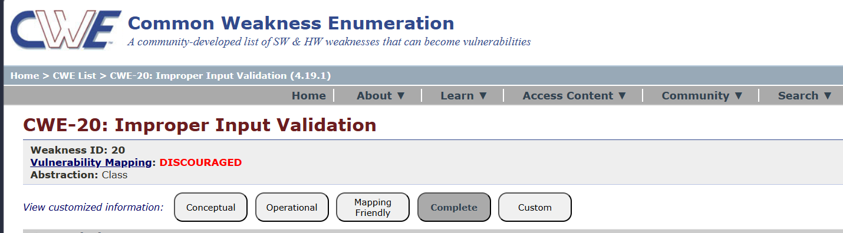

6. Vulnerabilities Name:Interpretation conflict

CWE/CVE : CWE-436

OWASP/SANS Categories:A06:2025 Insecure Design

Description: Product A handles inputs or steps differently than Product B, which causes A to perform incorrect actions based on its perception of B's state.

Business Impact:Insecure Design refers to design-level security flaws where the application architecture or business logic is created without proper security controls or threat modeling. Unlike coding bugs, this issue exists in the system design itself.

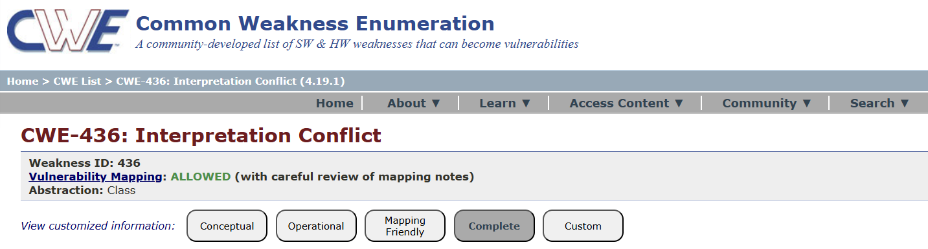

7. Vulnerabilities Name:Improper Authentication

CWE/CVE : CWE-287

OWASP/SANS Categories:A07:2025 Authentication Failures

Description:when an actor claims to have a given identity, the product does not prove or insufficiently proves that the claim is correct.
Business Impact:Authentication Failures when an application improperly implements authentication mechanisms, allowing attackers to bypass login systems or impersonate legitimate users.

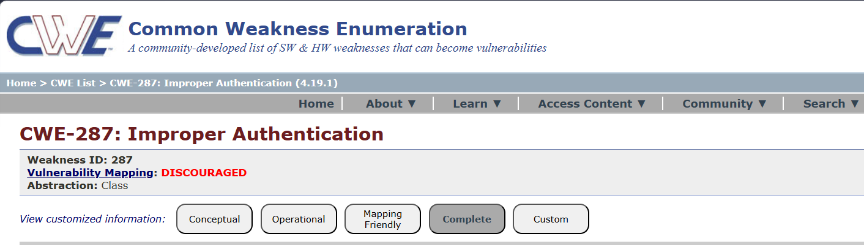

8. Vulnerabilities Name:Untrusted search path

CWE/CVE : CWE-426

OWASP/SANS Categories:A08:2025 Software or Data Integrity Failure

Description:The product searches for critical resources using an externally-supplied search path that can point to resources that are not under the product's direct control.

Business Impact:Software and Data Integrity Failures refers to vulnerabilities where verified for integrity, allowing attackers to modify or inject malicious code software updates, code, or data are not properly or data.

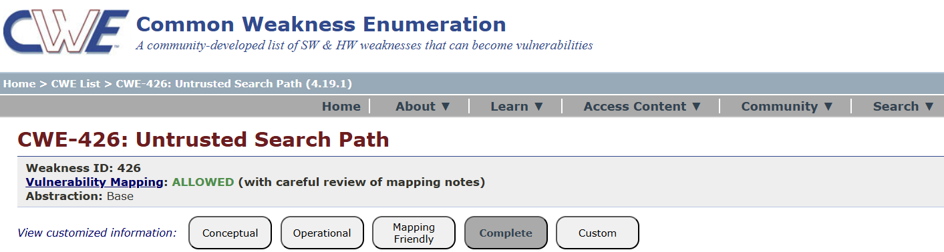

9.Vulnerabilities Name:Insufficient logging

CWE/CVE : CWE-778

OWASP/SANS Categories:A09:2025 Security Logging and Alerting Failures

Description: When a security-critical event occurs, the product either does not record the event or omits important details about the event when logging it.

Business Impact: Security Logging and Alerting Failures when an application does not properly log security events or fails to generate alerts when suspicious activity happens. This prevents organizations from detecting, responding to, or investigating security incidents effectively.

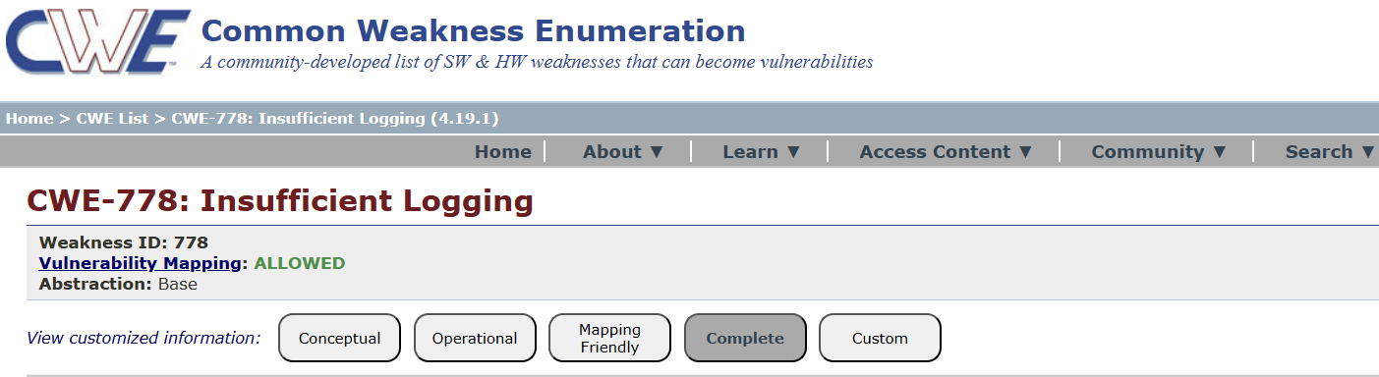

10.Vulnerabilities Name:Divide by Zero

CWE/CVE : CWE-369

OWASP/SANS Categories:A010:2025 Mishandling of Exception Conditions

Description: The product divides a value by zero.

Business Impact:Mishandling of Exception Conditions refers to situations where an application does not properly handle errors or unexpected conditions. Poor exception handling can expose sensitive information, crash systems, or create security loopholes that attackers can exploit.

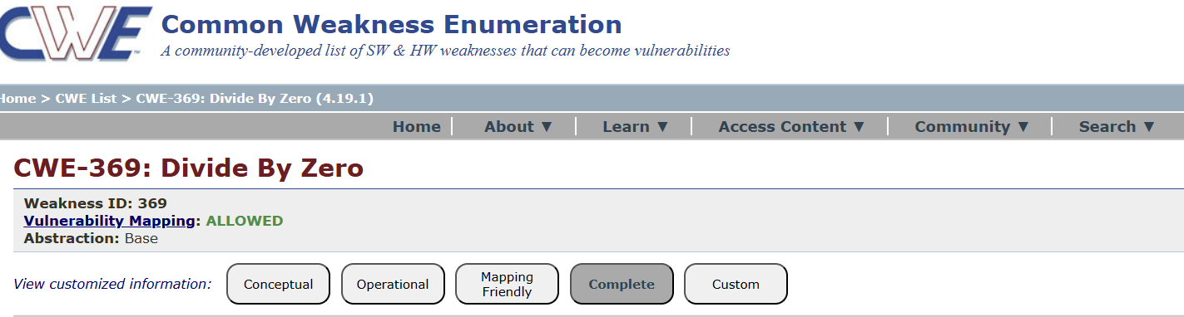

STAGE 2

TITLE: Nessus scan

Overview
Nessus is one of the most widely used vulnerability scanners in cybersecurity. A Nessus scan checks systems, networks, or applications for security vulnerabilities, misconfigurations, and compliance issues.
A Nessus scan automatically analyzes targets such as:
- Servers
- Network devices
- Databases
- Web applications
- Operating systems
- Cloud environments
It compares discovered services and configurations against known vulnerability databases (CVEs) and security best practices.

Example Scan Findings
A typical report may show:
- Outdated OpenSSL
- Weak SSH cipher configuration
- Missing OS patches
- Default credentials
A Nessus scan is a process used in cybersecurity to identify security vulnerabilities, misconfigurations, and weaknesses in computer systems, networks, and applications. During the scan, Nessus analyzes target devices such as servers, workstations, and network equipment by discovering active hosts, scanning open ports, identifying running services, and checking them against a large database of known vulnerabilities and security issues.It uses thousands of plugins to detect problems like missing patches, outdated software versions, weak configurations, and potential security risks.
List of Vulnerability

S.NO | Vulnerability name | Severity | Plugins ID
1 | Port scanner | INFO | 11219
2 | General | INFO | 54615
3 | settings | INFO | 19506
4 | Service Detection | INFO | 50845
5 | MISC. | INFO | 87242

REPORT:

1.Vulnerability Name: Port scanner

Severity: INFO

Plugins ID: 11219

Description:A port scanner is a cybersecurity tool used to identify open, closed, or filtered ports on a computer or network device. Ports are communication endpoints that allow different services, such as web servers, email servers, or file transfers, to interact over a network

Solution:By applying these security practices, organizations can significantly reduce the risks associated with port scanning and protect their network infrastructure from potential cyber attacks.

Business Impact:A port scanner vulnerability occurs when attackers can easily discover open ports and exposed services on a system using tools such as Nmap or vulnerability scanners like Nessus. If these open ports are not properly secured, they can create serious risks for an organization.

2.Vulnerability Name: General

Severity: INFO

Plugins ID: 54615

Description:A vulnerability is a weakness or flaw in a computer system, network, application, or security configuration that can be exploited by attackers to gain unauthorized access, disrupt services, or steal sensitive information.

Solution:To reduce and manage security vulnerabilities in systems and networks, organizations should implement several security best practices.

Business Impact:Security vulnerabilities in systems, applications, or networks can have serious consequences for organizations if they are exploited by attackers. When vulnerabilities are discovered using tools such as Nessus or Nmap, they indicate potential weaknesses that could be used to compromise systems.

3.Vulnerability Name:settings

Severity: INFO

Plugins ID: 19506

Description:A settings vulnerability occurs when a system, application, or network device is configured with insecure or improper settings that can expose it to security risks. These vulnerabilities often arise from default configurations, weak security controls, unnecessary services being enabled, or incorrect access permissions

Solution: Administrators should also disable unnecessary services, ports, and accounts that are not required for system operations, as these can increase the attack surface.

Business impact:Settings vulnerabilities—caused by misconfigured systems, weak passwords, default settings, or unnecessary services—can have significant consequences for a business. If exploited, attackers can gain unauthorized access to critical systems, leading to data breaches that compromise sensitive customer, financial, or proprietary information.

4.Vulnerability Name:Service Detection

Severity: INFO

Plugins ID: 50845

Description:A service detection vulnerability occurs when attackers can identify the services and applications running on a system or network and potentially exploit weaknesses in them. During network scans, tools like Nmap or Nessus can detect service types, versions, and configurations

Solution:To mitigate service detection vulnerabilities, organizations should implement proper service management and hardening practices. The first step is to identify all running services on systems and networks using tools like Nmap or Nessus.

Business Impact:A service detection vulnerability can have serious consequences for an organization if attackers exploit information about running services. By identifying exposed or outdated services, cybercriminals can target known vulnerabilities in applications, databases, or network services, leading to unauthorized access, data breaches, or system compromise

5.Vulnerability Name:Misc.

Severity: INFO

Plugins ID: 87242

Description:Miscellaneous vulnerabilities refer to security weaknesses that do not fit neatly into standard categories like port, service, or configuration vulnerabilities but can still pose significant risks to systems, applications, or networks

Solution:To address miscellaneous vulnerabilities, organizations should adopt a comprehensive security management approach. First, perform regular vulnerability assessments and security scans using tools such as Nessus to identify hidden or uncommon security weaknesses in systems, applications, and networks.

Business Impact:Miscellaneous vulnerabilities, although sometimes considered minor, can still create significant security risks for organizations. If these vulnerabilities are not properly addressed, attackers may exploit them to gain unauthorized access to systems, applications, or sensitive data

STAGE 3

Title: Application specific access polices using Zscaler private Access(ZAP)

Overview:

Application-Specific Access Policies using Zscaler Private Access (ZPA) – Overview
Application-specific access policies in Zscaler Private Access (ZPA) provide secure access to internal applications based on the Zero Trust security model. Instead of granting users full network access through traditional VPNs, ZPA allows organizations to define policies that give users access only to specific applications they are authorized to use. This approach minimizes the attack surface and prevents unauthorized lateral movement inside the network.
IDENTITY:
In Zscaler Private Access (ZPA), identity-based access is a key component of the Zero Trust security model. Instead of granting access based on network location or IP address, ZPA uses the user’s verified identity to control access to internal applications. This ensures that only authenticated and authorized users can access specific resources within the organization.
ZPA integrates with Identity Providers (IdPs) such as Microsoft ID, Okta, or other SAML-based authentication services. When a user attempts to access an internal application, ZPA verifies their identity through the configured IdP. After successful authentication, the system evaluates the access policies associated with that user or user group.
DEVICE POSTURE:
Device posture is an important factor in application-specific access policies within ZPA. It ensures that only secure and compliant devices are allowed to access internal applications. Instead of granting access solely based on user identity, ZPA also evaluates the security status of the device being used to connect.
Device posture checks verify whether the device meets the organization’s security requirements, such as having updated antivirus software, enabled firewall, latest operating system patches, disk encryption, or device management compliance. ZPA can integrate with endpoint management or security tools to collect this posture information before allowing access.
APPLICATION RISK:
Application risk refers to the security level or sensitivity of an application and how access to that application should be controlled. In Zscaler Private Access (ZPA), administrators can define application-specific access policies based on the risk level of different internal applications. This helps organizations apply stronger security controls to high-risk or sensitive applications.
Applications that handle confidential data, financial records, or critical business operations are typically considered high risk. ZPA allows administrators to enforce stricter policies for these applications, such as requiring multi-factor authentication (MFA), verified user identity, and compliant device posture before granting access
CONTEXT AWARE ACCESS:
Context-Aware Access – Application Risk in Application-Specific Access Policies using Zscaler Private Access (ZPA)
Context-aware access in ZPA allows organizations to make dynamic access decisions based on multiple contextual factors when a user tries to access an application. Instead of relying only on static rules, ZPA evaluates the context of the access request to determine whether the user should be granted, restricted, or denied access.
In the case of application risk, context-aware policies help apply different security controls depending on how sensitive or critical the application is. ZPA analyzes several contextual elements such as user identity, device posture, user location, time of access, and network conditions before allowing access to the application.

CONCLUSION:
Stage 1:
In the initial stage, organizations identify and classify their internal applications based on risk level and data sensitivity. Applications that handle critical business operations or confidential data are marked as high risk, while others are categorized as medium or low risk. At this stage, basic access policies are defined to ensure that only authorized users can access specific applications.
Stage 2:
In the second stage, organizations strengthen the access control by implementing identity verification and device posture checks. ZPA evaluates factors such as user identity, device security status, and authentication methods before granting access to applications. Higher-risk applications require stronger authentication and stricter security policies.
Stage 3:
In the final stage, organizations implement advanced context-aware access policies. ZPA dynamically evaluates multiple contextual factors such as user location, device compliance, time of access, and application risk level to make real-time access decisions. This ensures that sensitive applications receive stronger protection and access is continuously monitored.By implementing these stages, organizations can effectively manage application risk, enforce least-privilege access, and protect critical internal applications. Using ZPA’s Zero Trust approach ensures that users gain access only to the specific applications they need, while maintaining strong security controls across the organization.
FUTURE SCOPE:
Stage 1 – Improved Application Risk Classification
In the future, organizations can enhance the classification of applications based on risk levels using more advanced analytics. Automated systems can continuously evaluate application behavior, data sensitivity, and usage patterns to dynamically classify applications as high, medium, or low risk. This will help administrators apply more accurate security policies and quickly identify newly introduced or modified applications that may pose potential risks.
Stage 2 – Advanced Identity and Device Security Integration
Future improvements will focus on stronger integration with identity and device security platforms such as Microsoft Entra ID and Okta. This stage will enable adaptive authentication, stronger multi-factor authentication (MFA), and more detailed device posture checks. With better integration, access decisions can be based on real-time identity verification and device health status, further improving security.
Stage 3 – AI-Driven Context-Aware Access Control
In the advanced stage, future ZPA implementations may incorporate AI and machine learning to provide fully context-aware and adaptive security policies. The system could automatically analyze factors such as user behavior, network conditions, location anomalies, and application usage trends to detect suspicious activities. Access decisions would be made dynamically in real time, reducing manual configuration and improving threat detection.

Tools Explored : Owasp top 10,Scanning,Vulnerability,Awareness,Identity,Policy Configuration.
Topics Explored : Zscaler,Nessus,Owasp,Zscaler Private Access,Zscaler Zero Trust Exchange.

THE END

